ADICHUNCHANAGIRI INSTITUTE OF TECHNOLOGY
(Affiliated to VTU, Belagavi and Approved by AICTE, New Delhi)
Chikkamagaluru- 577 102, Karnataka, India.
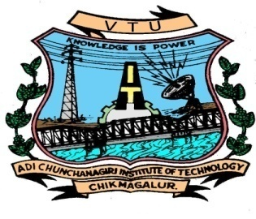
Department of Computer Science and Engineering

CERTIFICATE
This is to certify that the project work entitled “PICTURE PUZZLE GAME ” is a bonafide work carried out by PRERANA M V (4AI17CS070), SREERAKSHA TAPSE H (4AI17CS101) in partial fulfillment for the .NET mini project (17CS564) course of 5th semester Bachelor of Engineering in Computer Science and Engineering of the Visvesvaraya Technological University, Belagavi during the academic year 2019-20. It is certified that all corrections and suggestions indicated for Internal Assessment have been incorporated in the report deposited in the department library. The mini project report has been approved as it satisfies the academic requirements in respect of Mini Project Work prescribed for the said degree.

Dr. Sunitha M R _{B.E., M.Tech, Ph.D}
Professor
Dept of CS&E,AIT,
Chikkamagaluru.

Dr. Pushpa Ravikumar _{B.E., M.Tech.,Ph.D.}
Professor & Head,
Dept of CS&E,AIT,
Chikkamagaluru.

Signature of the Guide Signature of the HOD

